
Use Case
Presentation


Fascinating Project Ideas Presented
in a Clear and Concise Way

Submitted to:
Dr. Shazia

Submitted By:
Komal Shehzadi (Reg: 2016-CS-178)

Haris Khan (Reg: 2016-CS-105)
Hamza Farooq (Reg: 2016-CS-122)
Section:
Section B

Department:
Department of Computer Science

Institute:

University of Engineering and Technology Lahore (Main Campus)


Date of Submission:
March 6, 2018

Table Of Content
1. | Use Case UC1: Mac Registration------------------------------------------------------------------3
1.1 Description----------------------------------------------------------------------------------------3
1.2 Primary Actor-------------------------------------------------------------------------------------3
1.3 Stake Holders and interests---------------------------------------------------------------------3
1.4 Pre Conditions------------------------------------------------------------------------------------3
1.5 Success Guarantee (Post Conditions)----------------------------------------------------------3
1.6 Basic Flow-----------------------------------------------------------------------------------------3
1.7 Extensions-----------------------------------------------------------------------------------------4
1.8 Data Flow Diagram------------------------------------------------------------------------------4

2. | Use Case UC2: Online Library Catalog----------------------------------------------------------5
2.1 Description----------------------------------------------------------------------------------------5
2.2 Primary Actor-------------------------------------------------------------------------------------5
2.3 Stake Holders and interests---------------------------------------------------------------------5
2.4 Pre Conditions------------------------------------------------------------------------------------5
2.5 Success Guarantee (Post Conditions)----------------------------------------------------------5
2.6 Basic Flow-----------------------------------------------------------------------------------------5
2.7 Data Flow Diagram------------------------------------------------------------------------------6

3. | Use Case UC3: Airport Management-------------------------------------------------------------7
1.1 Description----------------------------------------------------------------------------------------7
1.2 Primary Actor-------------------------------------------------------------------------------------7
1.3 Stake Holders and interests---------------------------------------------------------------------7
1.4 Pre Conditions------------------------------------------------------------------------------------7
1.5 Success Guarantee (Post Conditions)----------------------------------------------------------7
1.6 Basic Flow-----------------------------------------------------------------------------------------7
1.7 Data Flow Diagram------------------------------------------------------------------------------8

4. | Use Case UC4: Bike Courier App-----------------------------------------------------------------9
1.1 Description----------------------------------------------------------------------------------------9
1.2 Primary Actor-------------------------------------------------------------------------------------9
1.3 Stake Holders and interests---------------------------------------------------------------------9
1.4 Pre Conditions------------------------------------------------------------------------------------9
1.5 Success Guarantee (Post Conditions)----------------------------------------------------------9
1.6 Basic Flow---------------------------------------------------------------------------------------10
1.7 Data Flow Diagram-----------------------------------------------------------------------------10

Use Case UC1: Mac Registration
Description: This use case describes how the User can register his device’s mac address in a Network Router.
Primary Actor: User, Network Administrator
Stakeholders and Interests:
- User: Wants user-friendly interface and wants Secure, fast browsing.

- Admin: Approves the authorized user’s request to internet access.
Wants to give internet access to limited and selected users only.

- Company: Wants to satisfy user interests.

Preconditions: User must have a WiFi compatible device.
Success Guarantee (Post Conditions):
- ‘Registration Screen’ displays Mac Registration Screen for user device’s mac address registration.
- ‘Terms and conditions Screen’ displays detailed legal information about the legal use of internet and conditions provided by Internet service provider.
- ‘Control Screen’ displays the accessed urls and data usage of individual user. Can control the internet speed of user. Keeps a record of Browsing History of each user but not keeps log of user’s sensitive data.

Basic flow:
- User opens a web browser, gives the URL for the ‘SeaWays Mac Registration’ website, Enters the Registration credentials and clicks on ‘Register’ button.
- System sends the registration request to Network Admin.
- Registration Request is added to queue for approval by the Network Admin.
- Admin approves the user’s mac registration requests that were added in queue for approval in step 3 on the basis of entered user data.
- If the user is approved by Admin then its WiFi device has access to internet.
- If provided information doesn’t seem valid then the user cannot even connect the device to WiFi.
- If user request is not processed yet then the ‘pending’ is shown on SeaWays Mac Registration’ website

Extensions (Alternate Flow):
5a. Admin can control the network speed of user and can restrict access to limited websites only.

6a. If user’s device doesn’t meet the network requirement then the registered user is then disqualified.

Data Flow Diagram:

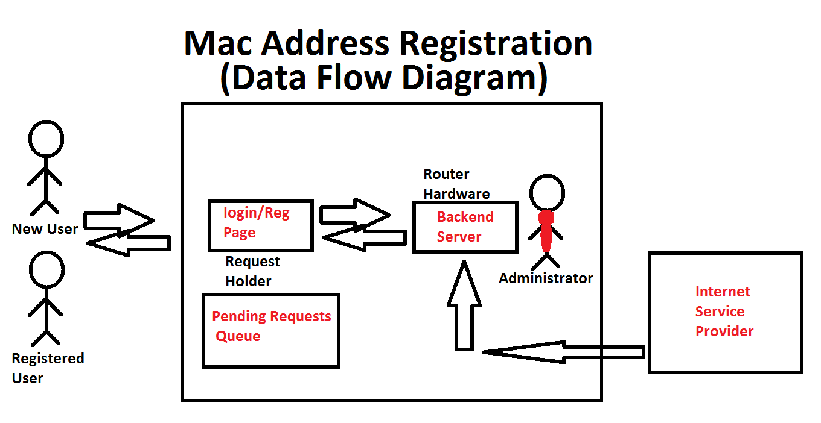

Use Case UC2: Online Library Catalog
Description: This use case describes how the User can search/browse the Online Library catalog.
Primary Actor: User
Stakeholders and Interests:
- User: Wants user-friendly interface and fast browsing speed.
Wants to browse the catalog and Read the required book easily.
Want to buy an e-book or hard copy on the embedded online store.
- Parhlo Website Owner: Every user who visits the site or makes a purchase has a direct bearing on the revenue and hence the profitability of the Website owner.

Preconditions: None.
Success Guarantee (Post Conditions):
- ‘Browse e-books Screen’ displays items, its logical size and related list prices for a chosen e-book.
- ‘Reading Screen’ displays the required page to be read by user in the selected e-book.
- ‘Item Screen’ displays detailed information about an individual e-book for sale, including the book cover, if one is available.
- ‘Cart Screen’ displays the various book items added to the cart, the quantity and list price of each item and the Subtotal.
Basic flow:
- User opens a web browser, gives the URL for the ‘Noor e-store’ website in and clicks on ‘Go’ button.
- System launches the web site and user gets itself logged in by using valid credentials.
- New User can register itself in the Website by providing valid Registration details. User must enter the following information
Contact Information:
- First Name
- Last Name
- Street Address
- City
- State of Province
- Country
- Postal Code
- Telephone Number
- E-Mail Credit Card Information
- Card Number
- Card Type
- Card Expiry Date

- User clicks on any ‘e-books category’ link in the ‘Books’ list given in top-left corner of Webpage.
- System displays ‘Category Screen’ with the e-books or related eye consumable items available for the category chosen in Step 4.
- User clicks on any book product link in ‘e-books for this Category’ list.
- System displays ‘Product Screen’ with list of all of the items for the product chosen in Step 6 along with the price of each item and a link labeled ‘Add to Cart’ in right column of the list.
- System displays ‘Item Screen’ for the item chosen in Step 7, including a book cover if one is available and an ‘Add to Cart’ link.
- User can subscribe to a study plan with paying fixed amount and can have access to read all books on the website for a limited time.

Data Flow Diagram:

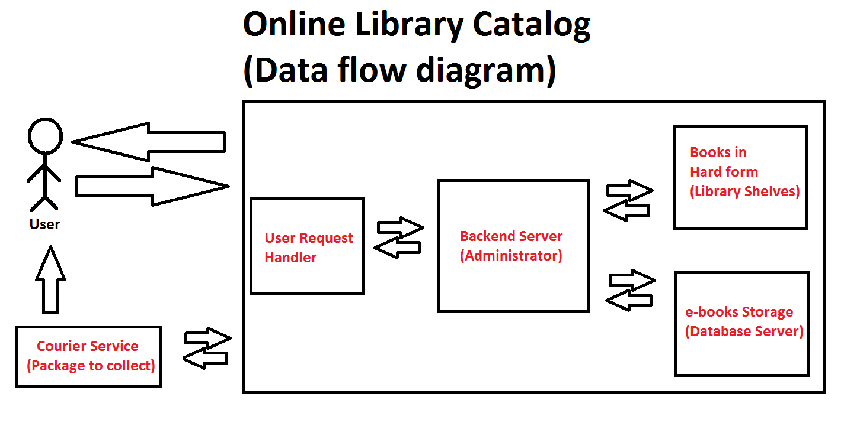
Use Case UC3: Airport Management
Description: This use case describes how the different Users can perform check-in and checkout the flight tickets.
Primary Actor: User, Airport Management
Stakeholders and Interests:
- User: Wants to get a proper guide from receptionist and perform
checkout for flight.
Wants a procedure applied for quick flight booking.
- Officer: Any faculty member of the Airport .
Wants to provide the user ease and make the user to take the most
of good management system.

- Company: Wants to satisfy user interests.

Preconditions: User must have a passport.
Success Guarantee (Post Conditions):
- ‘Receptionist’ guides the user and provides the necessary information and requirements for ticket registration.
- ‘Flight check-in system’ controls the incoming and outgoing flights to and from the Airport.
- ‘Ticket checkout system’ provides the tickets for flights and schedule the flights depending upon time and availability of planes.
Also controls the type of flight (i.e passenger or cargo flight).
- ‘Security System’ keeps an eye on every user check-in, baggage checking and prevents user to walk in restricted area or Admin area.
Basic flow:
- User enters the airport through security check.
- User along with its baggage is checked temporarily and not scanned thoroughly.
- User gets the required information from the receptionist.
- If the user has flight ticket then ticket is collected at ‘bookings counter’ then user is ready to checkout for flight.
If the user has not a flight ticket and then he have to register him then buy ticket or user can simply get a tour plan/package.
If the user has to send parcel then cargo plane is booked.

- User/parcel is sent into deep security check area in which user and its baggage is deeply scanned depending upon which type of flight is chosen in step 4.
Items that don’t fulfill the requirements are recaptured and user has to pay fine for that item.
- User/parcel is now added in a queue and then sent to the corresponding plane type.
- When the flight is ready, Pilot officer is called for takeoff from the airport runway.
- When Plane is arrived at runway, all the user and baggage/parcel is sent to deep security check.
- When the security check process in step 8 is completed then user and baggage/parcel is allowed to depart the Airport.

Data Flow Diagram:

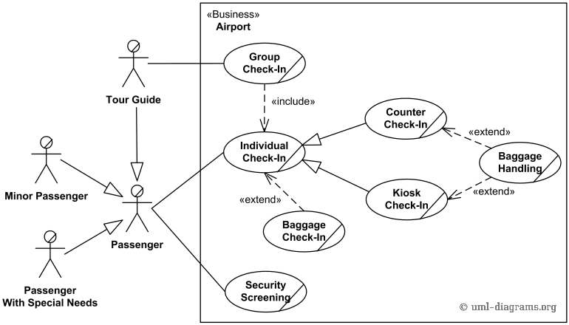

Use Case UC4: Bike Courier App
Description: This use case describes how the different Users can deliver the parcels from their current address to any postal address just by clicking the Bike Courier App.
Primary Actor: User, Motorist
Stakeholders and Interests:
- User: Wants to deliver the parcel from his current address to
another address securely and quickly.
Wants tracking information of the parcel after departure.
- Motorist: A registered faculty member and wants to earn money.
Wants to provide the best service to the user and get best rating
from user.

- GoBro App Owner: Every user who downloads and uses the app, make a transaction has a direct bearing on the revenue and hence the profitability of the App owner.

Preconditions: User must have ‘GoBro’ app installed in his
smartphone passport.
Motorist must have a working motorbike.
Success Guarantee (Post Conditions):
- ‘Customer UI’ of the ‘GoBro’ App is designed and specified for User consumption.
- ‘Motorist UI’ of the App is designed and specified for Motorist’s activity.
- App requires the following permissions for installation
Contact Information:
- Contact information
- Device Information
- GPS Access
- Cellular Network Access
- GPRS Network Access

- ‘Backend Server’ controls and monitors the flow of data to and from the User and Motorist
Basic flow:
- User/Motorist opens the app and login.
- If User/Motorist don’t have an account, then signup for the suitable account.
- User selects the location at which parcel is to be sent.
- User searches for service and any nearby motorist becomes active and quickly response.
- At the Motorist’s arrival, user handover the parcel and payment paid by suitable payment method or just hand over cash.
- Motorist takes the parcel and departs for destination.
- User and the Receiver can access the tracking information of Parcel.
- Success message is delivered on the phones of both users when parcel is successfully delivered.
- User can now rate the Motorist and also give feedback and suggestions for improvement.
Data Flow Diagram:
